Student Enrollment & Course Management System (SECMS)

TITLE: Student Enrollment & Course Management System (SECMS)

COLLEGE NAME: Sanghamam college of arts and science

DEPARTMENT: BCA

TEAM SIZE: | 5

TEAM MEMBERS: Sathishkumar.V

Sathish.S

Shaam.s

Sharmila begam

Sumithra.R

Student Enrollment & Course Management System (SECMS)

User Story:

The Student Enrollment & Course Management System is a comprehensive Salesforce application designed to streamline and automate the academic enrollment operations of an educational institute. This system enables administrators, enrollment officers, and instructors to efficiently manage student records, course offerings, enrollments, instructor assignments, approval processes, payments, and reporting—all within a unified Salesforce environment. 1. INTRODUCTION 1.1 Project Overview : This project aims to centralize all student, course, and enrollment-related data within a single Salesforce application to ensure easy data access, structured workflows, and accurate reporting. The system allows Enrollment Officers to manage student admissions, course registrations, and communication effectively, while instructors and administrators gain full transparency into course allocations and academic progress. The solution also enables automated instructor assignment, task creation, validation checks, and multi-level approval processes for enrollment management. With Salesforce Flows, Approval Processes, Validation Rules, Reports, and Dashboards, the organization can ensure that all enrollment operations—from admission to course completion— are handled systematically and with continuous monitoring of key performance indicators such as enrollment volume, revenue, student status distribution, and pending approvals.

1.2 Purpose :

The primary purpose of SECMS is to replace manual and fragmented enrollment processes with a scalable, automated, and secure Salesforce solution that ensures: Accurate student data management Structured enrollment workflows Automated approvals and validations Transparent reporting and monitoring
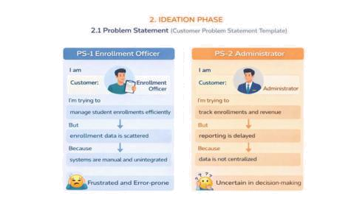

Empathy Map Canvas User Personal:

Enrollment Officer

  - Think & Feel: Concerned about double bookings and revenue loss

  - Hear: Complaints from students and management

- See: Multiple spreadsheets and emails

  - Say & Do: Rechecks data, follows up manually

  - Pain: Duplicate entries, approval bottlenecks

- Gain: Automation, dashboards, faster processing
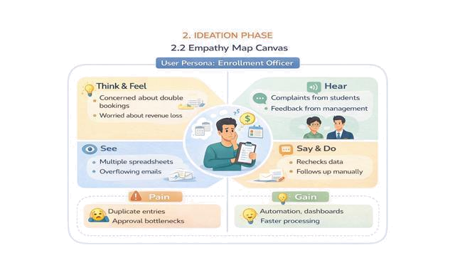

Brainstorming & Idea Prioritization:

Step 1 – Brainstormed Ideas

- Spreadsheet automation

- Standalone enrollment portal

  - ERP integration

- Salesforce-based enrollment system Step 2 – Grouping

- Manual solutions

- Semi-automated solutions

- Fully automated cloud solutions

3.REQUIREMENT ANALYSIS PHASE

3.1 Customer Journey Map Stages covered:

- Awareness & Registration

- Course Selection

- Enrollment Request

- Fee Payment

- Approval

- Instructor Assignment

- Reporting & Completion
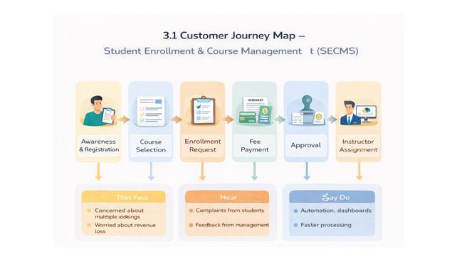

Non-Functional Requirements

NFR-1:

Usability Auto-assign instructors Dashboards and reports The system shall provide a simple, intuitive, and user-friendly interface that enables enrollment officers, administrators, instructors, and students to perform operations efficiently with minimal training. Navigation shall be organized through clearly labeled tabs, dashboards, and forms to reduce user effort and errors.

Examples:

  - Quick student registration form

- One-click enrollment approval

- Role-based dashboards

NFR-2:

Security The system shall ensure the confidentiality, integrity, and protection of student and institutional data through secure authentication, authorization, and access controls. Sensitive information such as personal data, enrollment history, and academic records shall only be accessible to authorized users.

Examples:

  - Only admins can modify course details

- Instructors view only assigned students

- Students cannot access other student records

NFR-3:

Reliability The system shall operate consistently and accurately without failures during enrollment processing, approvals, and reporting. Automation logic shall execute correctly to avoid duplicate or incorrect enrollments.

Examples:

- No duplicate course registration

  - Accurate status updates after approvals
● Consistent report generation

NFR-4:

Performance The system shall provide fast response times for all operations to ensure smooth and uninterrupted user experience, especially during peak admission periods.

Examples:

- Quick dashboard refresh

- Fast search for student records

- No lag during bulk uploads

Data Flow Diagram

  - User inputs student and enrollment data

- System validates and stores records

- Approval process routes data

- Reports and dashboards consume processed data.

The system processes enrollment requests, validates data, routes approvals, assigns instructors, and generates reports.
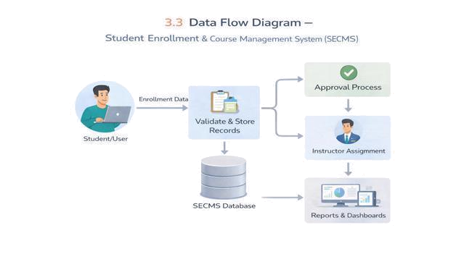

PROJECT DESIGN PHASE

4.1 Problem–Solution Fit SECMS directly addresses fragmented enrollment workflows by aligning user behavior, constraints, and automation using Salesforce-native capabilities.
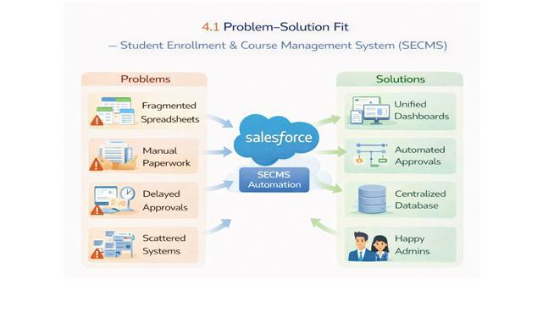
Solution Architecture

The architecture integrates Salesforce objects, automation flows, approval processes, dashboards, and security layers.
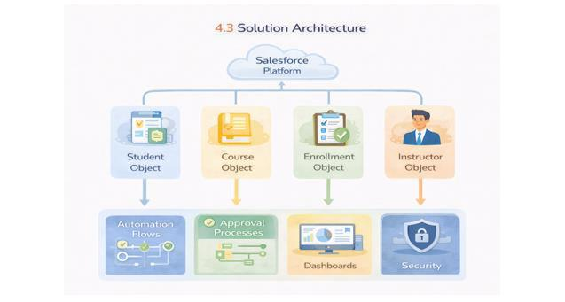

Project deployment phase:

Student enrolment& course management:

Student enrollment and course management systems centralize, automate, and streamline the entire student lifecycle—from recruitment and application to registration and retention. These digital platforms reduce administrative workload, provide real-time data on enrollment numbers and capacity, and enhance communication between students, faculty, and staff.
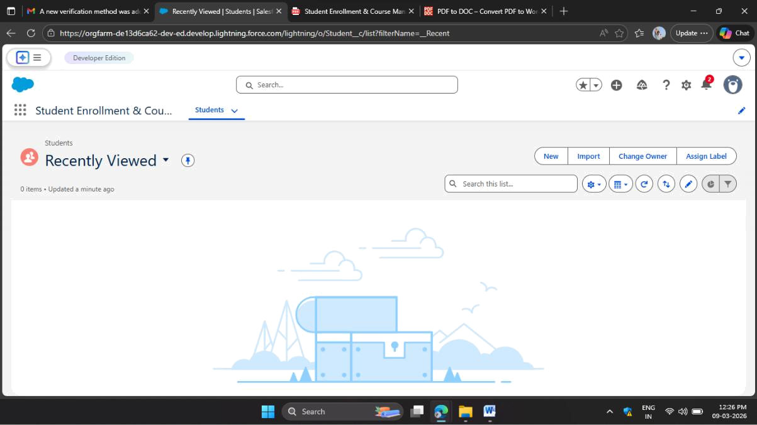

Student field creation:

Creating custom student fields allows educational institutions to store, track, and manage specific information—such as allergy details, transportation methods, or unique IDs—that are not covered by default system fields. These

fields are typically added to student profiles within a Student Information System (SIS), Learning Management System (LMS), or CRM to improve data accuracy and reporting.

Object manager:

The Salesforce Object Manager is a centralized hub within Setup used to manage standard and custom objects, allowing administrators to define data structures, such as a "Student" custom object, and add custom fields. Key

tasks include defining field data types (e.g., Student ID, Email) and configuring page layouts for data entry
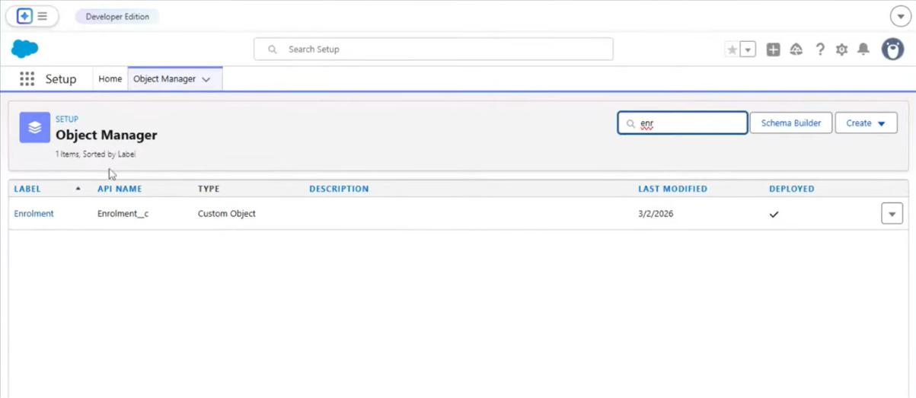

Enrolment phase:

The enrollment phase is a structured, multi-stage process designed to transition individuals (students, participants, or users) from initial interest to
active participation in a program, course, or system. It involves gathering

necessary documentation, verifying eligibility, confirming intent, and finalizing registration
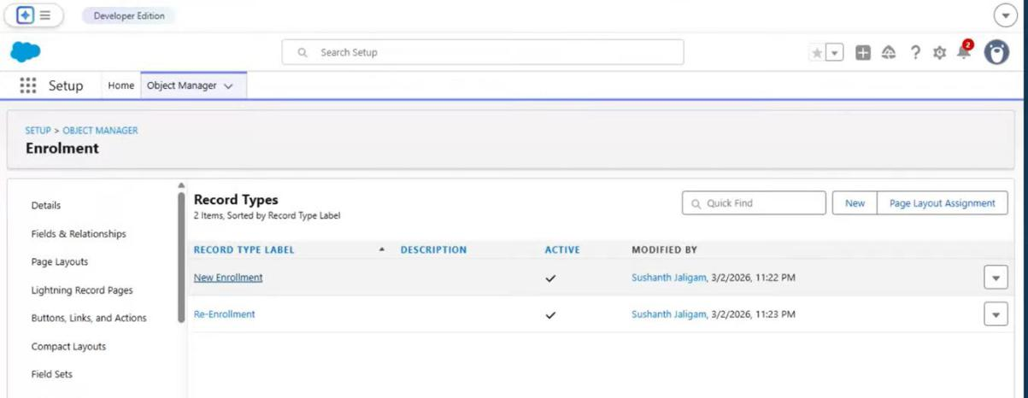

Student tab creation:

The "Student Overview" or "Students" tab is a common interface feature in educational software and student information systems (SIS) used by educators and administrators to manage and monitor learner data
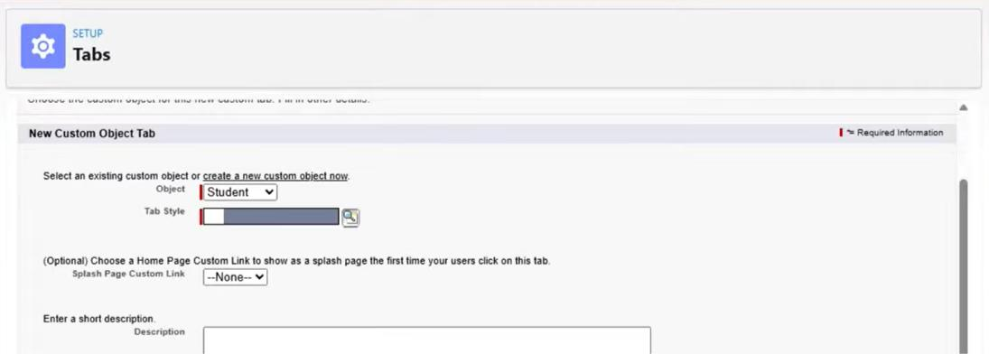
Final result:
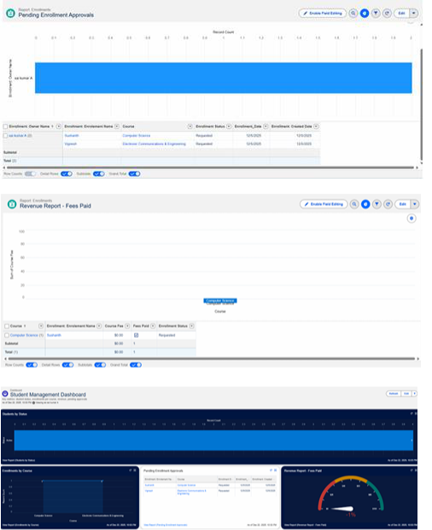

ADVANTAGES & DISADVANTAGES

Advantages

  - Centralized data

- Automated workflows

  - Real-time reporting
Disadvantages :

- Salesforce dependency

- Requires initial configuration effort

FUTURE SCOPE:

- Payment gateway integration

- Student self-service portal

- Analytics-driven insights

- Mobile access support

Conclusion:

The Salesforce Student Enrollment & Course Management System successfully streamlines the entire student academic lifecycle—from student registration and course creation to enrollment management, instructor assignment, approvals, revenue tracking, and reporting. By leveraging Salesforce’s automation tools such as validation rules, flows, approval processes, and dashboards, the system improves data accuracy, operational efficiency, and decision-making. This project demonstrates how Salesforce can transform manual academic processes into a scalable, reliable, and user-friendly digital solution.

THANK YOU!

